Chapter II
BACKGROUND STUDY
This chapter is written to give a general overview about humanoids, the history behind this technology, its development over the years and where researchers have reached in this field today. The different techniques and methods used to solve the problem humanoid stability will be compared. Moreover, the diverse approaches to increase humanoid robots’ sense of awareness and consciousness will also be discussed. this chapter contains summaries and conclusions that researches came to in this field to solve problems similar to the ones this thesis aims to solve. The research phase in any study is as important as phase in which the results are collected. Taking a closer look at the work of previous studies in the sector of humanoid stabilization helps in taking root in the method used in this thesis to come to an enhancement in the previous stability control algorithms. This chapter is divided into two sections, Literature Review and State of the Art; Literature review papers reflect a broader view about history, background knowledge and development. State of the art papers reflect the present state of scientific or engineering development in the field.

Literature Review

Historical Background

Designed in 1495 is the mechanism of the first humanoid robot by Leonardo da Vinci. Figure 2 depicts the Knight robot as the mechanical skeleton of the robot was covered by a full suit of armor. The links are connected with pulleys and cables to give the robot the ability to sit up, wave arms, move its head along with opening and closing its jaw [5]. This design was them up in action by the Duke of Milan by programming the mechanism as it was designed and also programming it to play drums [6].
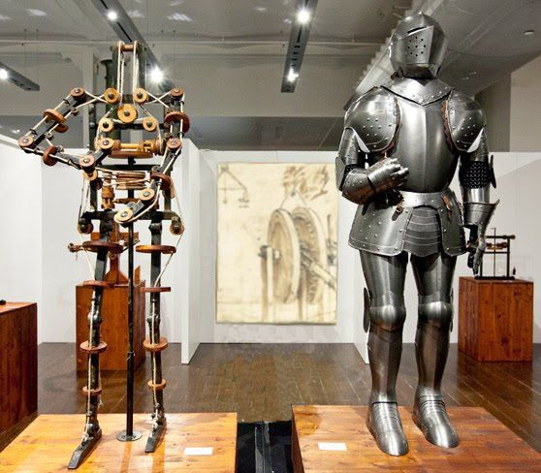
Figure 1. Knight Robot
The first humanoid robot was worked in 1495 by Waseda University in Japan and was called WABOT-1, which represents WAseda RoBOT 1. Despite the fact that not implanted, it could walk, perceive and control some visible items along with recognizing communicated language and voice [7]. Its next variant, WABOT-2, was presented twelve years later with the amazing ability of playing the piano [8].
The development and improvement time of humanoid starts in the nineteenth century when John Brainerd developed the Steam Man in 1865. It was moved by steam-motor and used to pull trucks. In 1885 the Electric Man was worked by Frank Reade Junior which was pretty much an electric form of the Steam Man. Figure 3 depicts the robot Steam Man on the left and its updated version Electric Man on the right. [9]
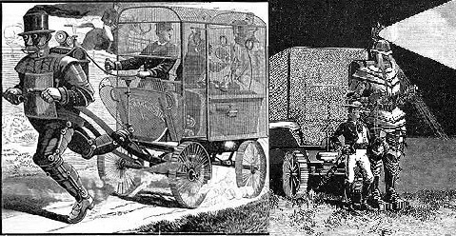
Figure 2. Steam Man and Electric Man
A growing number of humanoid systems and designs appeared during twentieth century. Toward the start of this century the Westinghouse society built a human like robot called ELEKTRO in 1938 shown in figure 4, designed to walk, talk and smoke. Since 1960s to 1990s, various kinds of legged robot began to show up in USA, Russia, France and particularly in Japan. An extraordinary work on a jumping robot was done at Massachusetts Institute of Technology (MIT) in 1980s. The Biped Planar, Spring Flamingo, Spring Turkey, Uniroo and 3D Biped were implemented in MIT having important accomplishments on walking and also running mechanisms in a dynamic and stable steps [9].
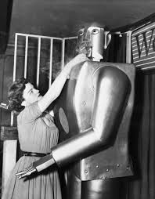
Figure 3. ELECTRO the Smoking Robot
In 1980s, researchers started concentrating stability while walking and improving the posture by enhancing the legs the walking mechanism of humanoid robots. Miura and Shimoyama established a biped robot series BIPER which was unstable while standing but dynamically stable while walking. BIPER-4 robot, depicted in figure 5, had non-motorized articulation at the ankles, large feet and inflexible knees.
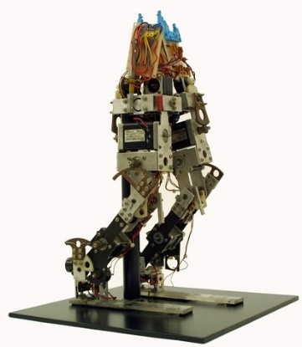
Figure 4. BIPER-4

The development of humanoid robots was remarkably taking place in Japan as the Waseda University was the first to invest in this field by having the first working humanoid designed WABOT-1. A team from Waseda University led by professor Kato also worked on a collection of legged robots during the twentieth century called Waseda Legged (WL). The series of WL robots went from WL-1 which was constructed in 1967 all the way through WL-3 WL-5 constructed in 1972. As the main purpose of these researches was about bipedal locomotion and improving the movement of these bipedal mechanisms, automatic biped walking and the ability to change direction while walking was made possible with WL-5. With improved mechanism of this series was then used at the lower limb of the first working humanoid WABOT-1. Walking forward and backward was implemented by the introduction of rotary servo actuators (RSA) [5].
Next, the artificial muscles made of rubber were introduced which were used as actuators in 1969. They were used as actuators in WPA-1. These powerful pouch-type artificial muscles were used for automatic posture control by also using pressure sensors under the feet in WPA-2. The first three dimensional biped walking was achieved by Kato in the design of WPA-3 in 1971. It was able to walk on a flat surface by keeping its center of gravity in the frontal plane. It was also able to go up and down the stairs or ramps and change its direction while walking. This mechanism was used for WL-5 which was then used as the lower link of the first humanoid WABOT-1 [5].
The study on the humanoid robot WABOT was started in 1970s. WABOT-1 was released in 1973 as the first fun-scale anthropomorphic intelligent robot developed in the world with a limb-control system, a vision and conversion system. This robot was given the ability to communicate with Japanese people and also measure its distance from objects around it using external sensors, artificial ears, eyes and mouth. It is able to walk with its lower limbs and also grab and move objects using tactile-sensors. It was also analyzed that WABOT-1 has the mental ability of an 18-year-old child [10].
WABOT-2, the specialist robot as in was called as it was designed in 1984 to play music on keyboard instruments in a very intelligent manner by reading normal musical notes in a visual sense and play the notes on an electronic organ. WABOT-1 and WABOT-2 are both depicted in figure 6 respectively from left to right [10].

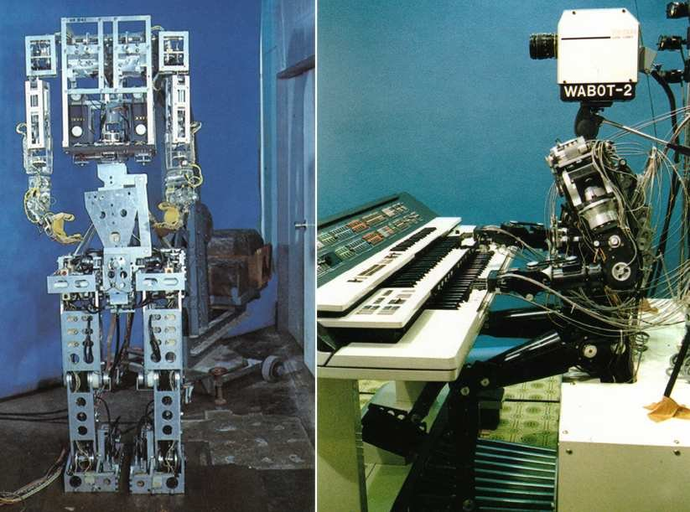
Figure 5. WABOT-1 and WABOT-2
Also in Japan, Honda designed a series of humanoid robots that ran from E0 to E6 starting in 1986, and continued with P1, P2 and P3 until it reached the most intelligent humanoid robot, Advanced Step in Innovation Mobility or ASIMO which is a robot that was given the capability of running. The Honda Humanoid series in depicted in figure 7 [11].
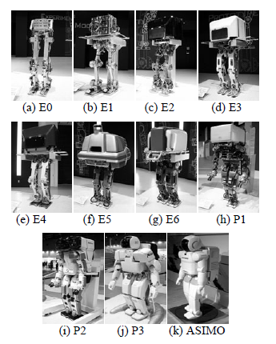
Figure 6. Honda Humanoid Series
First version of ASIMO was 1.2m high with 26 DOF and was mobilized using electric motors. The latest version is established in 2005 having 1.3m high and 34 DOF. This latest humanoid robot was given the capability of Running in straight path as well as circling path as well as circling path which is considered and advancement. Basic specifications of Honda Humanoid series are shown in table 1 [11].
Table 1. Specifications of Honda Humanoid Series
Series | Year | Weight (kg) | Height (cm) | DOF | Walking (Kmh⁻¹) | Running (Kmh⁻¹)
E0 | 1986 | 016.5 | 101.3 | 06 | 5.00 seconds between steps | No
E1 | 1987 | 072.0 | 128.8 | 12 | 0.25
E2 | 1989 | 067.7 | 132.0 | 12 | 1.20
E3 | 1991 | 086.0 | 136.3 | 12 | 3.00
E4 | 1991 | 150.0 | 159.5 | 12 | 4.70
E5 | 1992 | 150.0 | 170.0 | 12 | Slow
E6 | 1993 | 150.0 | 174.3 | 12 | Slow
P1 | 1993 | 175.0 | 191.5 | 30 | Slow
P2 | 1996 | 210.0 | 182.0 | 30 | 2.00
P3 | 1997 | 130.0 | 160.0 | 28 | 2.00
ASIMO | 2000 | 052.0 | 120.0 | 26 | 1.60 | 6.0 (straight) 5.0 (circling)
 | 2005 | 054.0 | 130.0 | 34 | 2.70

Along with the researches carries out in japan, researches in France were conducted simultaneously. First only the role legs and feet was mainly concentrated on in the researches working on bipedal robot in 1993 in Strasbourg University LSIT laboratory in France. The biped robot BIP2000 shown in figure 8, was designed and built by the INRIA Rhone-Alpes and LMS Poitiers. It was 1.8 meters high and having a weight of 105 kg with a locomotive system that helps it walk with gaits that are close that of humans as it had 12 basic mobilities. It was one of the system in which static stability was remarkable to a level that the robot was able to walk at a speed of 0.36 kmh⁻¹ [9].
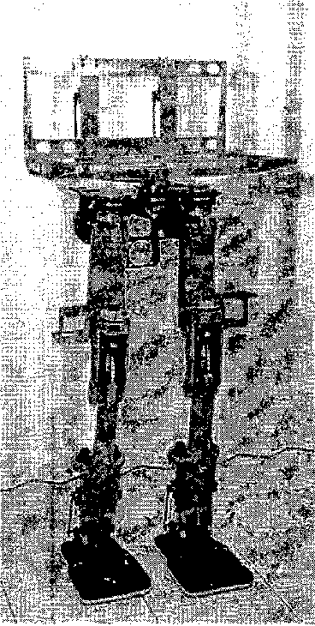
Figure 7. BIP2000 Robot
Expecting to set up walking and running gaits, the RABBIT project was begun in 1998 with CNRS Grenoble, the Frence bipedal robot community. The framework had a couple DOF and each of the gearboxes of the engines was able to deliver a most extreme force of 150 Nm which was fundamental for running gaits. The LIRIS Laboratory at the University of Versailles made a test human biped named ROBIAN in 2004. It had a three-dimensional kinematic architecture with 16 DOF. This 1.30m high robot weighs was 29kg and its foot was designed to be an articulated forefoot along a cross-over pivot moved with a link. The mechanical design of the trunk had three moving weights that help the robot in its maneuverability [9].

Exploration exercises in the field of human mechanical technology are growing quickly. Since the departure of ASIMO robot by Honda and AIBO robot by Sonny, robot fever has broken out in Japan. Thoughtful and fundamental studies about humanoid robots are carried out effectively for the future of humanoid robotic technology. In 2002, a little however generally quick strolling independent humanoid robot was designed having 17 DOF at Technical University Berlin, Germany [12]. An automated humanoid robot was structured in College of Queensland, Australia. The mechanical structure of a human bipedal robot was conveyed out at the National University of Singapore in 2003. The College of Genova, Italy, structured and created two a long time old youngster like humanoid robot called iCub in 2006. In 2000, a progression of KAIST Humanoid Robot (KHR) was created in Korea. KHR-0 which was created in 2001 had 2 legs without chest area. KHR-1 was created on the reason for research about biped strolling which had 21 DOF without any hands and head. The target of KHR-2, 41 DOF humanoid frameworks, was to build up the humanoid framework which could walk on the living-floor with human-like appearance and development. KHR-3 also called HUBO, have more human-like characteristics as it can be seen in figure 9, developments and human-friendly character. HUBO started being known from the year 2005 [5].
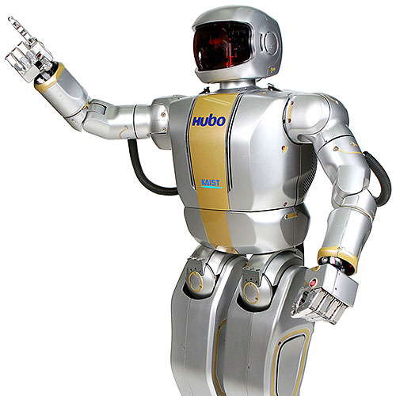
Figure 8. HUBO
The HOAP3 humanoid robot stage supplements the one that was introduced at the LAAS CNRS, Toulouse, France in June, 2006. HOAP3 is shown in figure 10. From 28-31 Walk 2002 ROBODEX2002 (www.robodex.org) was held in Yokohama where a sum of 28 exhibitors, counting 13 organizations, ten colleges, three gatherings were launched with various humanoid robots; ASIMO (Honda), Robovie II, Robovie III (ATR), Guardrobo C3, C4 (Sogo Keibi Hosho), SDR-4X (Sony), Dream Force 01 (Takara), PINO (Tsukuda Unique), QC-SR, Tmsuk04 (Tmsuk Co. Ltd), BN-7, BN-8 (Bandai), HOAP (Jujitsu Automation), Posy (SGI Japan and Flower Robotics), Morph (Japan Science and Innovation Corp. Kitano Symbolic Systems Project), HRP-1S, HRP-2P (Manufacturing Science and Innovation Center), The Shadow (The Shadow Robot Organization, UK). Also colleges were appearing with their humanoid related achievements with YANBO III (Tokyo Institute of Innovation, Hirose Laboratory), SAYA (Science College of Tokyo. Kobayashi Laboratory), KARFE (Nippon Engineering College of Engineering), Mecharobo (Nippon Bunri University, Hirakoso Research facility), Easy Going Daddy-1 (Hosei University, Takashima Laboratory), High Bar Gymnastic Robot, Saxophone-performing Robot, MARI-1, MARI - 2 (Yokohama National University, Kawamura Laboratory), WAMOEBA-2Ri, I SHA, WE-4 (Waseda University, Humanoid Laboratory), Magdan (Kyoto University, Takahashi Laboratory) [5]

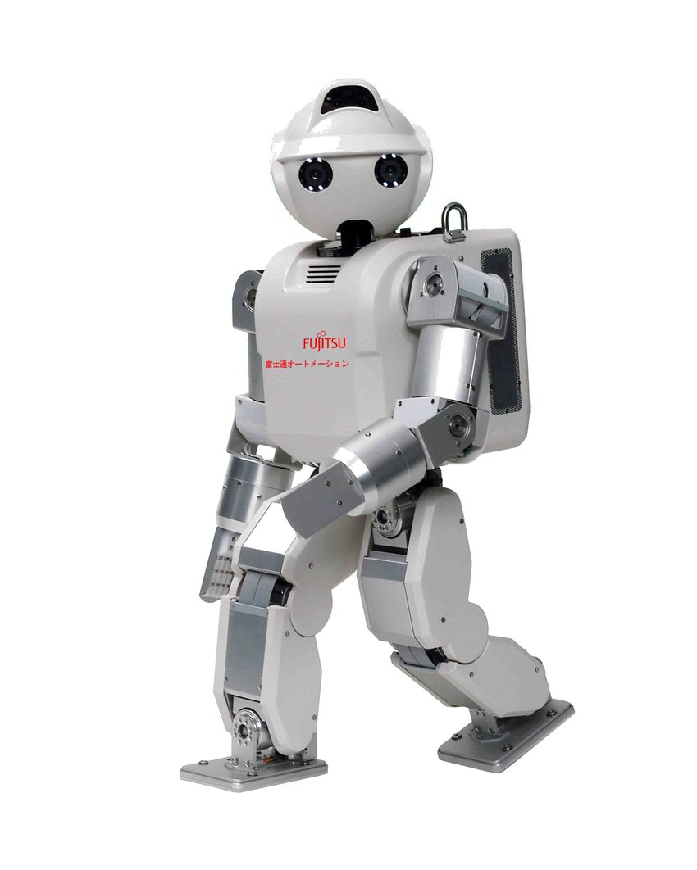
Figure 9. HOAP3

Romeo is a humanoid robot that was modeled and built before the end of 2011. The project is attempted by an alliance of organizations and national labs in France with the expectations to build up a humanoid robotic system that will have the option to help the old and outwardly tested individuals at home. The robot will be a 1.2 to 1.5-meter high bipedal intelligent machine and people could speak with voice or even signs. The framework likewise could assist an individual with getting up if there should arise in case of a fall. The arranging organization in this venture is Aldebaran Robotics, which creates and sells the littler and clever humanoid robot NAO. Both robots NAO and Romeo are shown in figure 11 respectively from left to right [13]. In Malaysia a little size humanoid, Malaysia Boleh, was created with the cooperation between Universiti Teknologi Malaysia (UTM) and Cytron Technologies Sdn. Bhd. [14]. It had the option to adjust itself while walking and standing still on slanted floor. Even turning, moving, push up was accomplished in this robot. IRobo was a human like robot created in International Islamic University Chittagong (IIUC), Bangladesh which was skilled to get objects, wiping floors and perform other basic chores. Siddiky's IRobo, created in 2007, had some uncommon knowledge.
to react to some voice orders [15].

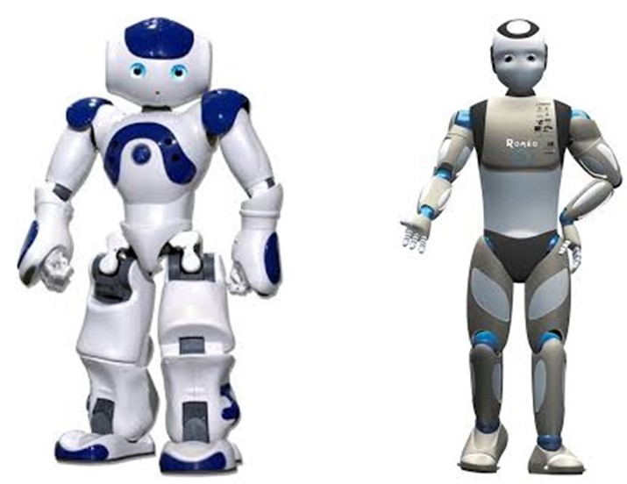
Figure 10. NAO and Romeo

Experimentations on humanoid robots for the use to perform a diversity of tasks were still happening in 2008. With Rollin' Justin a mobile automated system and research stage is introduced that promote the usage of such robots and exhibit modern control calculations. Significant issues of mobile advanced mechanics, for example, adaptable control and systems for utilizing the expanded workspace and repetition in control task can be concentrated in detail. The experimental work covers a diagram of the structure of the moving platform and design of the upper-body which was a table-mounted system at chest area first (Justin) and transform it into (Rollin' Justin), a completely self-supported mobile humanoid robot shown in figure 12 [16].

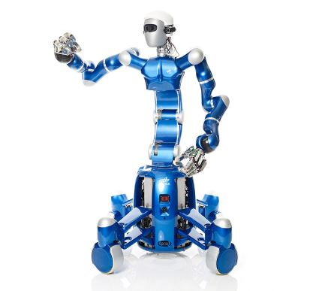
Figure 11. Rollin' Justin

Robonaut 2, considered one of the recent age of the Robonaut astronaut assistants, dispatched to the space station board space shuttle “Discovery” on the STS-133 mission in February 2011. It is the first humanoid robot in space, and despite the fact that its essential activity until further notice is exhibiting to engineers how capable robots act in space, the expectation is that, through updates and headways, it might one day be able to adventure outside the station to assist spacewalkers with troubleshooting or perform scientific work in the station. Work on the first Robonaut started in 1997. The thought was to manufacture a humanoid robot that could help space travelers on undertakings in which another pair of hands would be useful or to wander forward to perform occupations either excessively risky for individuals to or even unnecessary to waste time on. The outcome was R1, a human-like model of a robot that could perform tasks or be mounted on a lot of wheels to investigate far off objections. Through 2006, R1 acted in various investigations in an assortment of research center and field test conditions, demonstrating that the idea of an automated partner was reasonable. The very year, General Motors communicated an enthusiasm for hearing about the task. They had been building up their own robots, and seeing what NASA had achieved, GM proposed collaborating. A Space Act Agreement was marked in 2007 to permit GM and NASA to pool assets and work together on the cutting edge Robonaut.

In February 2010, R2 was uncovered – a quicker, more skillful, more mechanically advanced humanoid robot than had ever been seen previously. Its capability was immediately perceived, and it was taken on the space shuttle Discovery's last mission to the space station. It was the foremost humanoid robot working in space and progress as engineers get to see for the first time how a humanoid robot really acts without gravity [17].
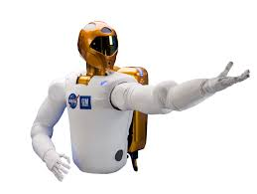
Figure 12. Robonaut 2

In February 2010, R2 was uncovered – a quicker, more skillful, more mechanically advanced humanoid robot than had ever been seen previously. Its capability was immediately perceived, and it was taken on the space shuttle Discovery's last mission to the space station. It was the foremost humanoid robot working in space and progress as engineers get to see for the first time how a humanoid robot really acts without gravity [17].

Manav is two-feet tall and resembles a toy that is large in size. It uses 21 sensors, two cameras in its eye attachments and two microphones on either side of its head. Manav is India's first 3D printed humanoid robot. Weighing 2kg, Manav which means man in Sanskrit, has a built in vision and sound handling capacity, permitting it to talk and act like a human. “The lower price point will allow more colleges to avail of it, and this plays in very well with the government’s recent ‘Make in India’ campaign. Besides, parts can be easily replaced at a reasonable cost since they are available in India," said Vaish. The robot has two degrees of freedom in its head and neck which help it move its head both, sideways and also longitudinally. Moreover, grabbers are being added to the robot’s arms so that it can lift objects [18].

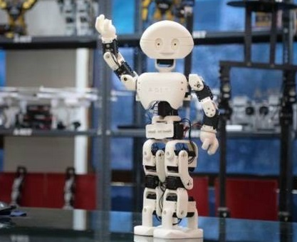
Figure 13. Manav

The world’s most dynamic humanoid robot is Atlas by Boston Dynamics. It is in its examination stage, intended to stretch the boundaries of full-body mobility. The parts of its skeleton are 3D printed aircraft-grade aluminum and titanium. It is made of two arms, two legs, a head and two hands which were designed by two different contractors; one by Sandia National Labs and the other by iRobot. When assembled, the humanoid is 1.5 m high and weighs 80 kg. The robot has an on-board real-time computer. Atlas’s high level control enables the robot to demonstrate human-level agility when it comes to its power and balancing. It is made of the world’s most compact hydraulic system. The robot’s mobility impressive due to the high power delivered to all 28 hydraulic joints. The motors, valves and the hydraulic power unit are assembled and configured to ensure that a high power is delivered to the joints of the humanoid. This incredibly dynamic robot is controlled by an advanced control system leading the system to perceive its environment via LIDAR and stereo vision technology, plan and move accordingly with a speed on 1.5 m/s. Atlas was disclosed on July 11 2013 by the Defense Advanced Research Projects Agency (DARPA) to help in emergency situations being able to be operated in dangerous areas. Atlas is trained to be able to avoid obstacles, walk on different terrains, manipulate static and dynamic objects. It can also perform backflips, jump over log lying on the grass and jump over objects [19].
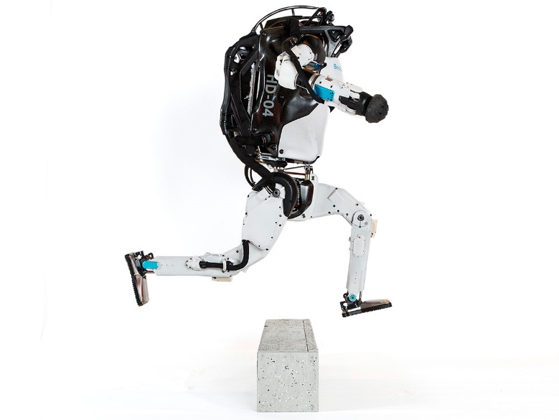
Figure 14. Altas

Posture Control and Balancing

Bipedal and humanoid robots require postural control and balancing for the performance of many tasks such as walking running jumping or even just in their static standing up-right position. Humans have always been superior to robots when it comes to the robustness in control of bipedal balancing, but with different approaches to tackle this issue due to the diversity of models discussed in the previous sections, this challenge is by some means overcome.

An article entitled “Simultaneous Prevention of Rotational and Translational Slip for a Humanoid Robot” which is a research conducted by Qinqin Zhou, Zhangguo Yu ,Si Zhang , Xuechao Chen , Mingyue Qin ,Weimin Zhang and Qiang Huang concentrated on controlling the posture and balancing humanoid robot on slippery surfaces. Since slip regularly happens in humanoid robots strolling, particularly when the robots stroll on a low friction surface or walk quickly. Surprising slip may make the robots fall and afterward result harm. In actual conditions, rotational and translational slip can occur while the robot is moving. In this research, they propose methodologies for rotational and translational slip counteraction dependent on a three mass model, which consider the results of the swing leg. The rotational slip is forestalled through a bionic strolling design generator which imitates the yaw moment compensation mechanism of a human. The translational slip is eliminated through a novel reaction force ratio reduction control with the compensation of CoM (center of mass) acceleration. The effectiveness of the presented strategies is validated by simulations and experiments with an actual humanoid robot [20].
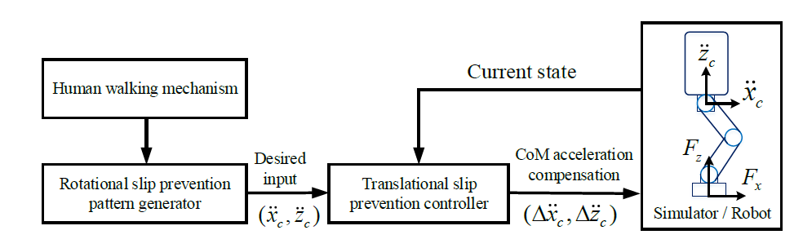
Figure 15. Overview of the Control Architecture for Translational and Rotational Slip Prevention

Another research conducted not necessarily for humanoid robots but also for human postural control and balance entitled “COMTEST Project: A Complete Modular Test Stand for Human and Humanoid Posture Control and Balance” was done by Vittorio Lippi, Thomas Mergner, Thomas Seel and Christoph Maurer. This research is about a system including a full workspace in which a humanoid under perturbations and different types of disturbance is monitored and is having his posture controlled and balanced. The disturbance on the robot is applied in different scenarios and the response is monitored using advanced algorithms and analysis software [21].
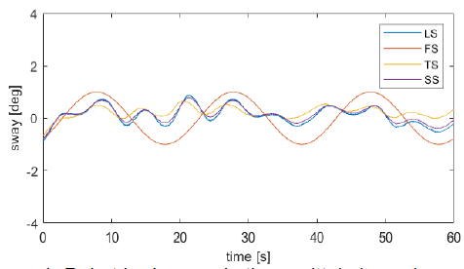
Figure 16. The Sway of Body Segments in Function of Time

A research entitled “Optimization Based Full Body Control for the Atlas Robot” by Siyuan Fengy, Eric Whitmanz, X Xinjilefuy and Christopher G. Atkesony emphasis on the full body control of the same humanoid targeted in this thesis. They chose the inverse kinematics as a complementary method to the inverse dynamics which they have used previously as the inverse dynamics model proved to provide the system with great robustness to external disturbances and the inverse kinematics only demands the kinematic model to be obtained which is not too expensive in terms of calculations in practice [22].
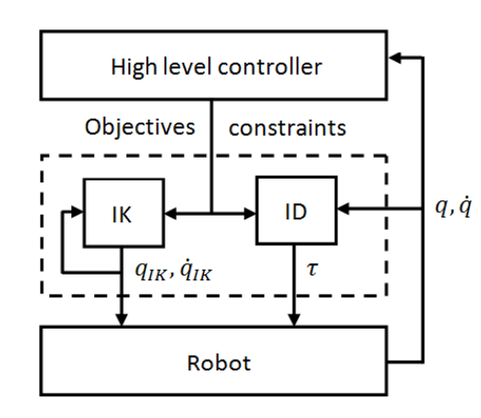
Figure 17. Flowchart with IK and ID in the System

Dynamics Stability

Most robots maneuvering in space and humanoid robots in specific are subject to forces to external forces that affect the static and also the dynamic stability of the robots. The robot gathers information from its surrounding using sensors mounted on the system to acquire data about the environment and feeds this data to the control algorithm to regain its dynamic stability and return to its steady state operation after a significant disturbance.

In a research entitled Alexis “Estimation of Contact Forces and Floating Base Kinematics of a Humanoid Robot Using Only Inertial Measurement Units”, Mifsud, Mehdi Benallegue and Florent Lamiraux were acquiring data from the robot’s surrounding and from the contact surface precisely and this data will then be fed to the control algorithm later. They were able to measure the contact forces and torques which help in predicting the balance. They aimed at estimating contact forces and torques and to observe the body kinematics of the robot with only an Inertial Measurements Unit (IMU). They showed that they are able to reconstruct efficiently the position of the Center of Pressure of the robot with only the IMU and proprioceptive data from the robot [23].

Mehdi Benallegue and Florent Lamiraux carried on n the research entitled “Estimation and Stabilization of Humanoid Flexibility Deformation Using Only Inertial Measurement Units and Contact Information” by only inertial measurement unites and sensors with the contact surface which were used for estimation of the deformation in the flexible parts responsible for the absorption of the impact and the stabilization of the HRP-2 robot. The IMUs serve the robot to recover its orientation based on gravity and inertia. Moreover, the humanoid’s contact with the ground affords steadfast data on surrounding environment. This study shows how important it is to take into justification these data to improve IMU-based position/orientation reconstruction. An extended Kalman fillter was used to rebuild the deformation, making the combination between IMU and contact information, and without making any assumption on the dynamics of the flexibility [24].

Ario Sunar Baskoro and Mark Gabriel Priyono in the research entitled “Design of Humanoid Robot Stable Walking Using Inverse Kinematics and Zero Moment Point” focused on tackling the issue of humanoid locomotion to form a standard stability model for a walking robot. Unlike other researches of humanoid robots that use the method of static walking or dynamic walking for its stability. The usage of static walking on robots emphasize on stability pose while dynamic walking emphasizes on its mobility efficiency. The Zero Moment Point and Inverse Kinematics in the combination of both walking methods that can achieve a stable and efficient humanoid robot movement and walking pattern. The result of humanoid robot stability margin is 3.44 mm and its velocity 8.11cm/s [25].

In the paper entitled “Work those Arms: Toward Dynamic and Stable Humanoid Walking that Optimizes Full-Body Motion” concentrated on the effect of the numerous actuators on the dynamic stability of the robot. Christian M. Hubicki, Ayonga Hereid, Michael X. Grey, Andrea L. Thomaz and Aaron D. Ames applied the study on a humanoid robot that has over 27 actuators. In other resources the dynamics stability concentrates on the movement of the legs and not the arms. Where as in this research they used the movement of the arms to enhance the stability. they also presenteds preparatory dynamic walking experiments with the humanoid in equipment, in this manner building a case that hybrid zero dynamics as expanded by inverse kinematics (HZD+IK) is becoming a reasonable approach for controlling the complete complexity of humanoid movement [26].

In the paper entitled “Stability Regions for Standing Balance of Biped Humanoid Robots”, Jung Hoon Kim, Jongwoo Lee and Yonghwan Oh worked out the control model to balance a standing humanoid relating it to a way similar to that of a linear inverted pendulum model. More accurately, two sorts of the stability regions are talked about in this research with the thought of that the zero moment point (ZMP) ought to be found within the supporting locale to ensure steady standing of the biped humanoid robots. To begin with, expecting no outside unsettling influences influencing the movement of the biped humanoid robots, the set of the introductory values of the center of mass (CoM) position and speed with which the area of the ZMP is restricted to be interior the supporting locale can be expressly gotten by measuring a limited number of direct disparities. Second, two allowable sets of outside constrain unsettling influences (impulse and finite energy) with which the ZMP does not go astray from the supporting locale are characterized by fathoming limited number of straight disparities or the discrete-time Lyapunov condition, separately [27].

Artificial Intelligence

Artificial Intelligence is an approach to make a computer, a robot, or a product to think how smart human thinks and this a main aim in the field of research related to humanoid robots. It is based on two key masts: data acquisition and the educated response of the robot. The enhancement of this performance is based on the training the machine receives and how good of a learning process it undergoes and this is the process called machine learning. So machine learning is an application of artificial intelligence (AI) that provides systems the ability to automatically learn and improve from experience without being explicitly programmed. Machine learning focuses on the development of computer programs that can access data and use it to learn for themselves.
The process of learning begins with observations or data, such as examples, direct experience, or instruction, in order to look for patterns in data and make better decisions in the future based on the examples that we provide. The primary aim is to allow the computers learn automatically without human intervention or assistance and adjust actions accordingly.
Supervised machine learning algorithms can apply what has been learned in the past to new data using labeled examples to predict future events. Starting from the analysis of a known training dataset, the learning algorithm produces an inferred function to make predictions about the output values. The system is able to provide targets for any new input after sufficient training. The learning algorithm can also compare its output with the correct, intended output and find errors in order to modify the model accordingly.
The performance of a machine learning algorithm is measured by calculating some machine learning metrics: A confusion matrix is a description of the outcomes of estimates on a classification problem. The amount of correct and incorrect predictions is explained with count values and subdivided by each class. This is the best approach to the matrix of confusion. The confusion matrix shows that, when making assumptions, the classification model is confused. It provides some insight not only into the errors made by a classifier, but also the types of errors made. Table 1 is an example of a confusion matrix that will be used to introduce some metrics [28].

Table 2. Confusion Matrix
 | Predicted
Actual |  | Negative | Positive
 | Negative | True Negative | False Positive
 | Positive | False Negative | True Positive

Accuracy is one metric for evaluating classification models. It is the fraction of the model’s correct predictions as shown in Equation 1. Equation 2 represents the precision which is the division of the total number of properly classified positive examples by the total number of predicted positive examples. High Precision indicates an example labeled as positive is indeed positive (small number of false positive). Whereas, recall can be characterized as the proportion of the absolute number of accurately arranged positive models gap to the total number of positive samples Equation 3. Since there are two measures (Precision and Recall) it assists with having an estimation that speaks to the two of them. F-measure in calculated to be uses Harmonic Mean in place of Arithmetic Mean as it punishes the extreme values more Equation 4. The F-Measure will always be nearer to the smaller value of Precision or Recall [29]. Below is the list of acronyms and equations representing the terms defined in this paragraph:

- TN: True Negative
- FN: False Negative
- TP: True Positive
- FP: False Positive

$$Accracy=\frac{TP+TN}{TP+TN+FP+FN}$$ | $$(1)$$
$$Precision=\frac{TP}{TP+FP}$$ | $$(2)$$
$$Recall=\frac{TP}{TP+FN}$$ | $$(3)$$
$$F-measure=2*\frac{Recall*Precison}{Recall+Precision}$$ | $$(4)$$

There are various algorithms used in supervised machine learning, which include k-Nearest-Neighbor, Linear Regression, LD3 (decision trees), Naïve Bayes and SVM. Supervised machine learning relies on labeled input data to learn an output when given new unlabeled data. It can be used in classification and regression problems [30].
A. K-Nearest Neighbor
In pattern recognition, k-NN is a non-parametric method used in supervised machine learning for solving classification and regression. It can be summarized using the saying “Birds of a feather flock together.” This means that the algorithm assumes similar features exist close to one another, and k stands for the amount of close features that need to be observed before prediction. K is also called a hyper-parameter. Other hyper-parameters include type of measurement and distance. There are two main metrics used, Manhattan and Euclidean.
B. Logistic Regression
Logistic Regression was used in biological sciences; it could be used when the dependent variable is categorical. An example would be predicting a tumor as malignant (1) or benign (0). This algorithm is not suitable for classification, but rather linear regression problem. It works using a cost function and a decision boundary [31].
C. Decision Tree
Decision trees have been widely used in real life and they influenced a wide area of machine learning covering classification and regression [29]. The main issue with decision tree is knowing which node it best to start with. This problem can be tackled using ID3 algorithm, which focuses on entropy in order to calculate the best root node and internal nodes used to find the optimal tree.

D. Naïve Bayes
Naïve Bayes focuses on probabilistic approach to classification problems. This algorithm is able to find the probability of an event A happening given that event B has occurred. Note that this is only true under the assumption of having independent features [32].

E. Support Vector Machine
This algorithm is the most powerful used today in machine learning. Its usage yields results with high accuracy and less computational power. Its main objective is to transform the classification problem from its original space to a higher dimension space (through kernels) that is easier; then, returning the result to its original space. SVM mainly focuses on producing a hyper plane separation through 2 support vectors. The optimal hyper plane will be able to separate 2 classes perfectly [32].

F. Ensemble Learning
An ensemble-based system is obtained by combining diverse models (henceforth classifiers). Therefore, such systems are also known as multiple classifier systems, or just ensemble systems. In order for this process to be effective, the individual experts must exhibit some level of diversity among themselves, as described later in this article in more detail. Within the classification context, then, the diversity in the classifiers – typically achieved by using different training parameters for each classifier – allows individual classifiers to generate different decision boundaries. If proper diversity is achieved, a different error is made by each classifier, strategic combination of which can then reduce the total error. Figure 1 graphically illustrates this concept, where each classifier - trained on a different subset of the available training data - makes different errors (shown as instances with dark borders), but the combination of the (three) classifiers provides the best decision boundary [33].
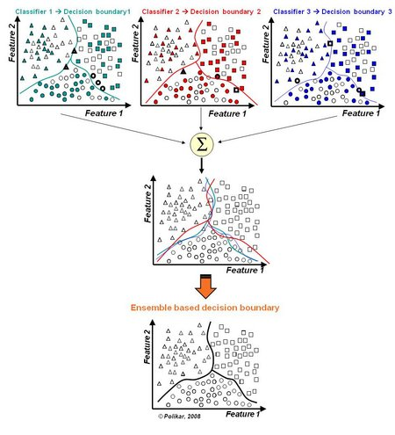
Figure 18. Ensemble Learning

The process starts with finding the appropriate dataset containing the features required for the classification to happen. Before using the data, it all has to be manipulated and prepared. Next features and the response of the classifier have to be declared and then the dataset has the be divided into it is divided into two sets; the training dataset consists of 70% of the data and the testing dataset consisting of the remaining 30%. All sets are introduced to the algorithm.

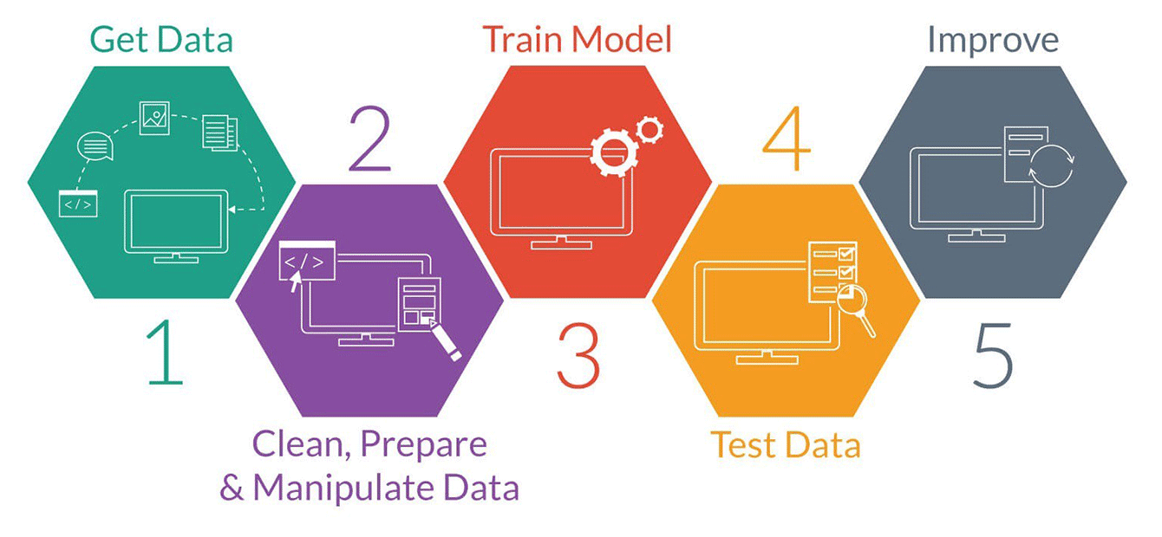
Figure 19.5 Steps of a Machine Learning Data Preparation Procedure

Antonio Paolillo, Andrea Cherubini, Francois Keith, Abderrahmane Kheddar and Marilena Vendittelli conducted a research entitled “Toward Autonomous Car Driving by a Humanoid Robot: A Sensor-Based Framework” in which they had an HRP-4 humanoid robot sit behind a steering wheel given the image of the road. The AI algorithm was able to extract features from the image based input inform of vectors and accordingly calculate the steering wheel angle required [34].

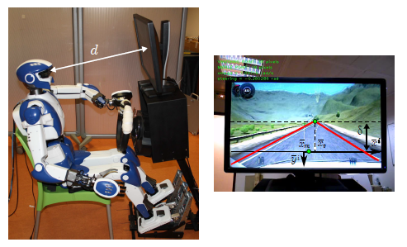
Figure 20. Experimentation Setting

In the research entitle “Robust Real-time Whole-Body Motion Retargeting from Human to Humanoid” motion was being transferred from human movement to a humanoid robot. Exchanging the movement from a human administrator to a humanoid robot could be a significant step to empower robots to memorize from and imitate human developments. The capacity to retarget in real-time whole-body movements that are challenging for the humanoid balance is basic to empower human to humanoid teleoperation. A retargeting system that permits the robot to imitate the movement of the human administrator acquired by a wearable movement capture suit, whereas keeping up the whole-body of the robot adjust using some filters. We present a few energetic channel in the retargeting to prohibit unsafe movements that can make the robot fall. We validate our approach through a few experiments on the iCub robot, which includes an altogether diverse body structure and estimate from the one of the human administrator [35].

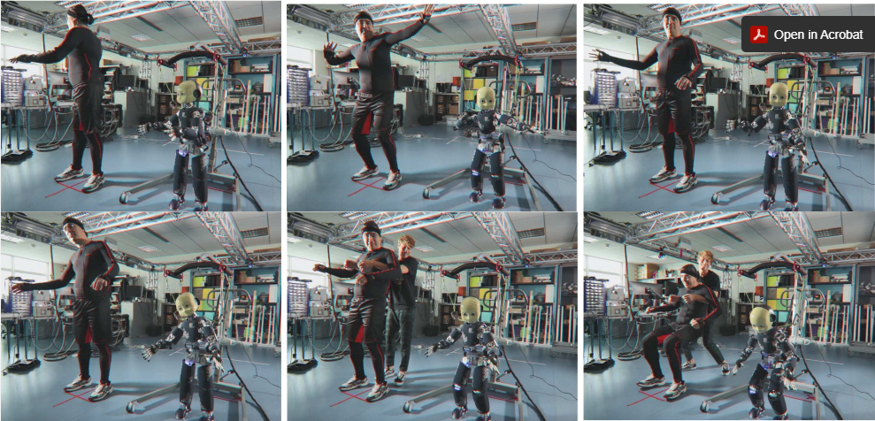
Figure 21. Humanoid Imitating Human Movement

Simulation Software

- ROS (Robto Operating System)
Robot Operating System is an open-source, meta-operating system for your robot. It provides the services you would expect from an operating system, including hardware abstraction, low-level device control, implementation of commonly-used functionality, message-passing between processes, and package management. It also provides tools and libraries for obtaining, building, writing, and running code across multiple computers. ROS is similar in some respects to 'robot frameworks,' such as Player, YARP, Orocos, CARMEN, Orca, MOOS, and Microsoft Robotics Studio.The ROS runtime "graph" is a peer-to-peer network of processes (potentially distributed across machines) that are loosely coupled using the ROS communication infrastructure. ROS implements several different styles of communication, including synchronous RPC-style communication over services, asynchronous streaming of data over topics, and storage of data on a Parameter Server. ROS is not a real-time framework, though it is possible to integrate ROS with real-time code. The Willow Garage PR2 robot uses a system called pr2_etherCAT, which transports ROS messages in and out of a realtime process. ROS also has seamless integration with the Orocos Real-time Toolkit [36].
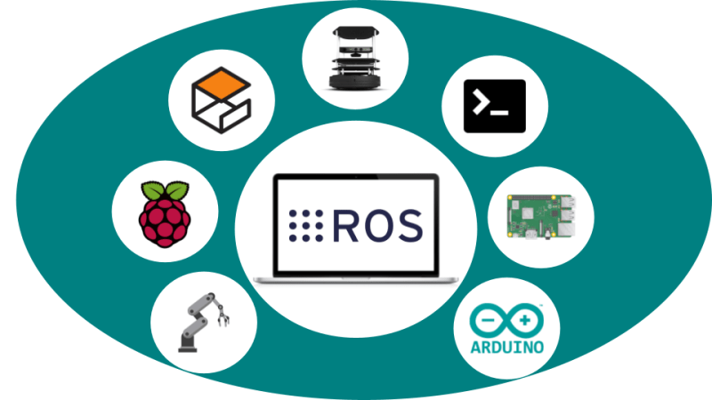
Figure 22. ROS and All Compatible Hardware and Software
The Computation Graph is the peer-to-peer network of ROS processes that are processing data together. The basic Computation Graph concepts of ROS are nodes, Master, Parameter Server, messages, services, topics, and bags, all of which provide data to the Graph in different ways.

Nodes: Nodes are processes that perform computation. ROS is designed to be modular at a fine-grained scale; a robot control system usually comprises many nodes. For example, one node controls a laser range-finder, one node controls the wheel motors, one node performs localization, one node performs path planning, one Node provides a graphical view of the system, and so on. A ROS node is written with the use of a ROS client library, such as roscpp or rospy.

Master: The ROS Master provides name registration and lookup to the rest of the Computation Graph. Without the Master, nodes would not be able to find each other, exchange messages, or invoke services.

Parameter Server: The Parameter Server allows data to be stored by key in a central location. It is currently part of the Master.

Messages: Nodes communicate with each other by passing messages. A message is simply a data structure, comprising typed fields. Standard primitive types (integer, floating point, boolean, etc.) are supported, as are arrays of primitive types. Messages can include arbitrarily nested structures and arrays (much like C structs).

Topics: Messages are routed via a transport system with publish / subscribe semantics. A node sends out a message by publishing it to a given topic. The topic is a name that is used to identify the content of the message. A node that is interested in a certain kind of data will subscribe to the appropriate topic. There may be multiple concurrent publishers and subscribers for a single topic, and a single node may publish and/or subscribe to multiple topics. In general, publishers and subscribers are not aware of each other’s' existence. The idea is to decouple the production of information from its consumption. Logically, one can think of a topic as a strongly typed message bus. Each bus has a name, and anyone can connect to the bus to send or receive messages as long as they are the right type.

Services: The publish / subscribe model is a very flexible communication paradigm, but its many-to-many, one-way transport is not appropriate for request / reply interactions, which are often required in a distributed system. Request / reply is done via services, which are defined by a pair of message structures: one for the request and one for the reply. A providing node offers a service under a name and a client uses the service by sending the request message and awaiting the reply. ROS client libraries generally present this interaction to the programmer as if it were a remote procedure call.

Bags: Bags are a format for saving and playing back ROS message data. Bags are an important mechanism for storing data, such as sensor data, that can be difficult to collect but is necessary for developing and testing algorithms.

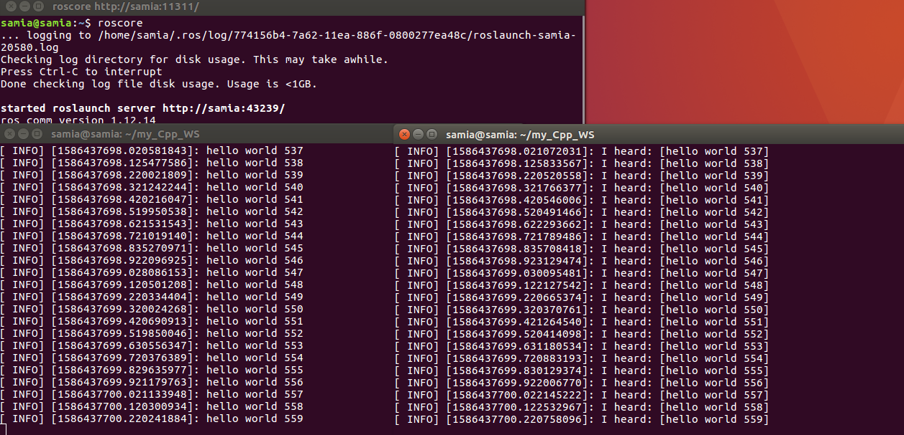
Figure 23. Publisher and Subscriber Node

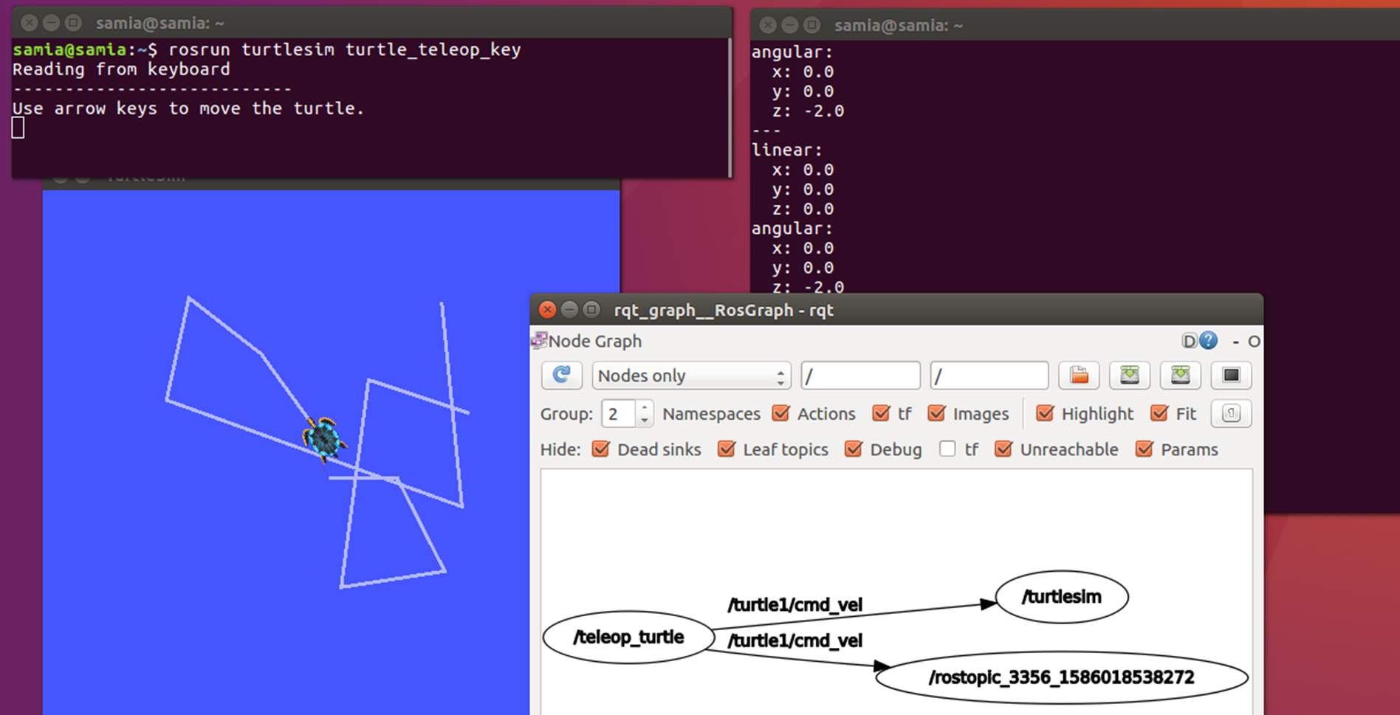

Figure 24. Example of ROS Computational Graph

- Gazebo


Figure 25. Gazebo Simulator logo
Robot simulation is an essential tool in every roboticist's toolbox. A well-designed simulator makes it possible to rapidly test algorithms, design robots, perform regression testing, and train AI system using realistic scenarios. Gazebo offers the ability to accurately and efficiently simulate populations of robots in complex indoor and outdoor environments. At the fingertips is a robust physics engine, high-quality graphics, and convenient programmatic and graphical interfaces. Utilizing OGRE, Gazebo provides realistic rendering of environments including high-quality lighting, shadows, and textures. Using Gazebo as a simulator the user can generate sensor data, optionally with noise, from laser range finders, 2D/3D cameras, Kinect style sensors, contact sensors, force-torque, and also develop custom plugins for robot, sensor, and environmental control. Plugins provide direct access to Gazebo's API. Many robots are provided including PR2, Pioneer2 DX, iRobot Create, and TurtleBot. Or build your own using SDF or a robot from scratch can be rendered [37].

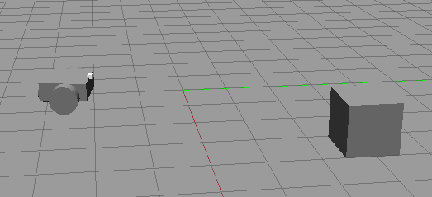
Figure 26. Gazebo Simulation Of an Object Follower

- Webots


Figure 27. Webots Robot Simulator Logo

Webots is an open source and multi-platform desktop application used to simulate robots. It provides a complete development environment to model, program and simulate robots. It has been designed for a professional use, and it is widely used in industry, education and research. Cyberbotics Ltd. maintains Webots as its main product continuously since 1998.
Webots allows users to design easily complete robotics simulations using the large Webots asset library which includes robots, sensors, actuators, objects and materials and also import existing CAD models (from Blender or from URDF). Import OpenStreeMap maps. It also allows users to create a wide variety of simulations including two-wheeled table robots, industrial arms, bipeds, multi-legs robots, modular robots, automobiles, flying drones, autonomous underwater vehicles, tracked robots, aerospace vehicles, and set-up indoor or outdoor interactive environments.

Webots core is based on the combination of a modern GUI (Qt), a physics engine (ODE fork) and an OpenGL 3.3 rendering engine (wren). It runs on Windows, Linux and macOS. Webots simulations can be exported as movies, interactive HTML scenes or animations or even be streamed to any web browser using webgl and websockets. Robot may be programmed in C, C++, Python, Java, MATLAB or ROS with a simple API covering all the basic robotics needs [38].

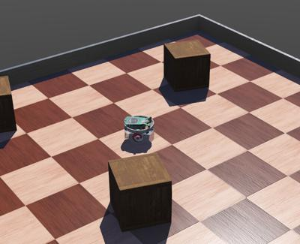
Figure 28. Webots Simulation - E-puck

State of the Art
Many researches have been conducted in this field and more precisely on humanoids and on the detection of external forces and the evaluation of disturbances with the use of sensors. But only few have resorted to the alternatives in which they reduced the number of sensor used to the minimal. And when in such systems sensors are not used a substitute can be one of a diversity of options and in this section the different approaches to solving the same problem to be solved in this thesis as mentioned in the first chapter will be mentioned.

In the paper “Multifaceted Humanoid for Surveillance & Monitoring”, Ashwin Dhande wrote about a humanoid that was designed to be sent in harsh environments for surveillance and monitoring. So it had to be given the ability to sense a diversity of external parameters such as temperature, pressure, pH, strain, humidity and much more. Therefore, the robot had to have paper-based artificial skin and this is to give the robot features for the robot to be able to replace humans in space [39].
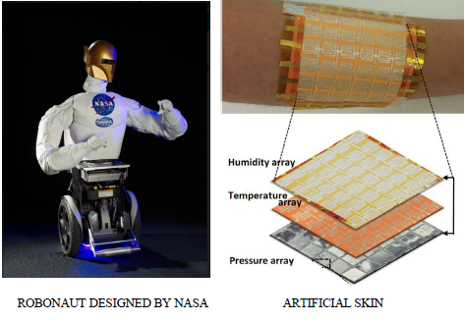
Figure 29. Artificial Skin Covering the Humanoid

Mehdi Benallegue, Pierre Gergondet, Herve Audren Alexis Mifsud, Mitsuharu Morisawa, Florent Lamiraux, Abderrahmane Kheddar, and Fumio Kanehiro conducted a research entitled “Model-Based External Force/Moment Estimation for Humanoid Robots with No Torque Measurement” in they avoided the use of force sensors that are usually placed on the feet and the wrists since they cost a lot. The dynamics of any robot and specially humanoids cannot be calculated unless the forced acting on the robot are declared. Usually this happens through data acquired through force and torque sensors whereas this paper estimation of the external force and the moments using an inertial mass unit on the robot [40].
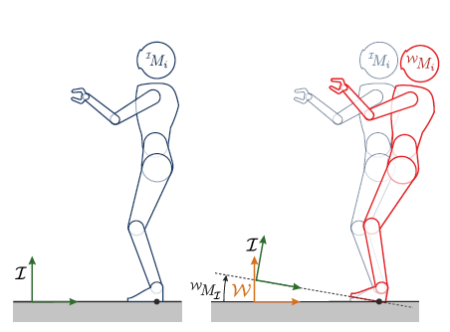
Figure 30. Humanoid Under the Effect of External Disturbance

In the “Sensorless External Force Detection Method for Humanoid Robot Arm based on BP Neural Network” Guoyu Zuo, Yongkang Qiu, Yuelei Liu and Xiangsheng Huang increases the intelligence of the robot arm, turned the robot’s responses into more educated ones and increased its safety by detecting external forces without the use of joint torque sensors which can detect the external force of the joint space in real time during the operation of the robot. Instead of detecting the force using sensors this will be done through a deep learning algorithm. Tests appeared that the strategy can effectively improve the location exactness, and the gotten external force location information can be connected not as it were to the collision detection within the inactive state of the robot, but too to the online collision location when the robot is running, which can ensure the secure operation of the robot [41].
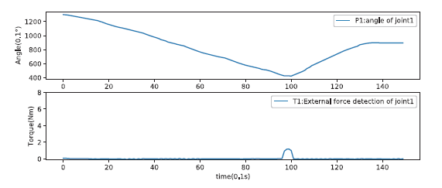
Figure 31. Measurement of Angle and Torque of the Motor at the Robot Joint
In the research “Force localized interaction sensing system for HYDROïD humanoid robot”, M. Tahoun, A. Tayba, S. Alfayad, A. Wahdan and L. Chassagne, presented a new type of low cost force localized sensor. It is dependent on mechanical deformation and mathematical models. This research is concerned with the localization of the force by distributing a set of sensors and fixing them a distance away from each other and relating them in a mathematical model in a 2 dimensional plane. A model within the 2 Dimensional arrange is built. A test verification of concept setup is outlined and sets of estimations outline constrain detecting comes about. A commercial sensor based on another innovation is utilized for reference [42].
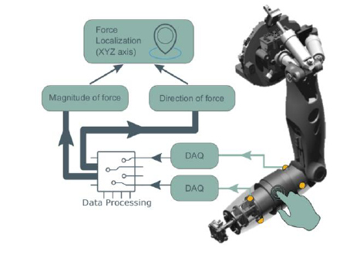
Figure 32. Distribution of Sensors of the Arm to Calculate the Force Direction and Magnitude

